**TUGAS INDIVIDU**

**PEMROGRAMAN BERBASIS FRAMEWORK**

**PERTEMUAN 2**



Disusun oleh:

**Rijal Ammar Irsyadul Ibad**

**TI-3B/2041720184**

**D4 TEKNIK INFORMATIKA**

**TEKNOLOGI INFORMASI**

**POLITEKNIK NEGERI MALANG**

**2023**

1. **Memproses Object pada JS**

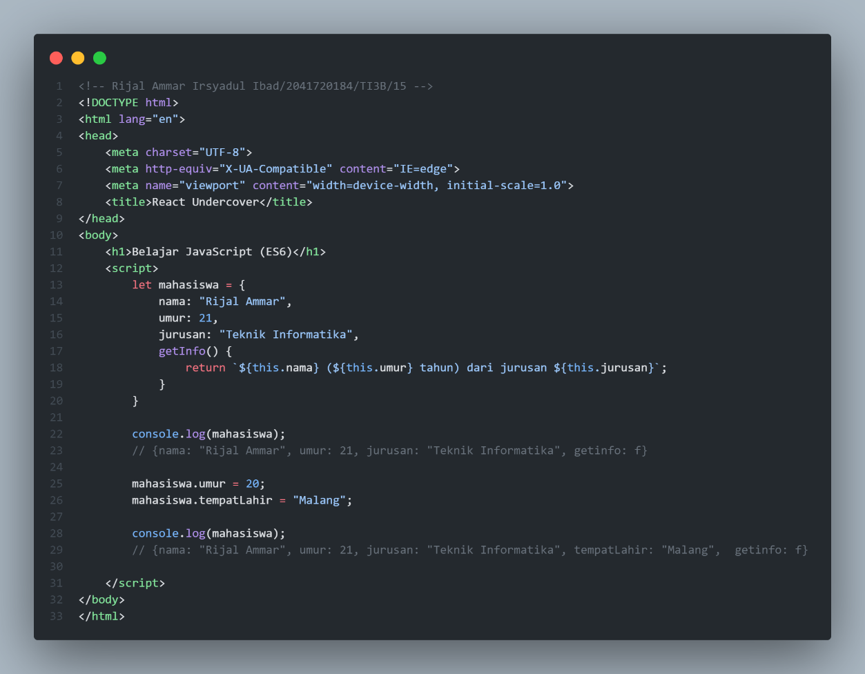

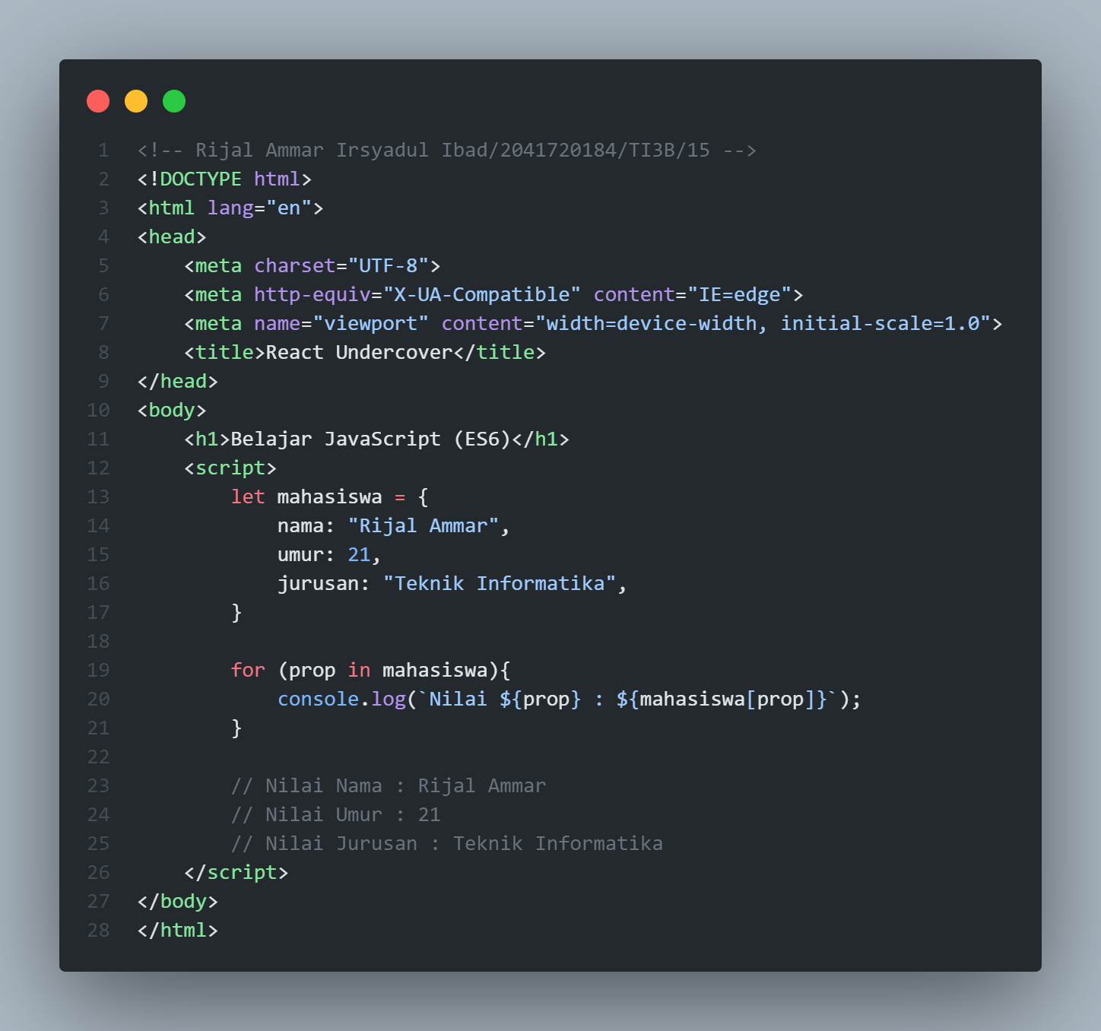

1. **Contoh Penggunaan Memproses Object pada JS**

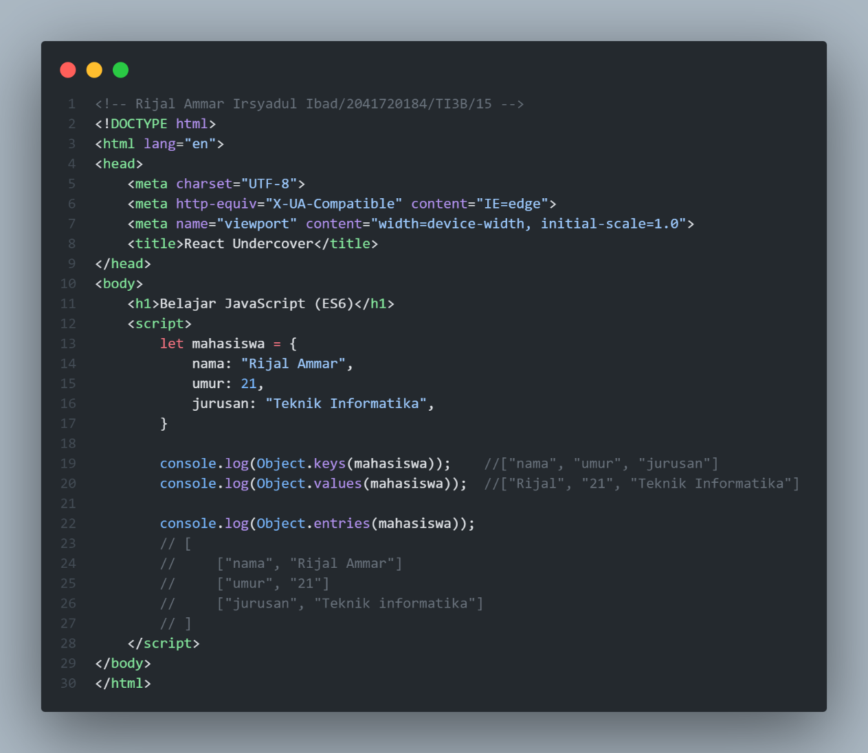

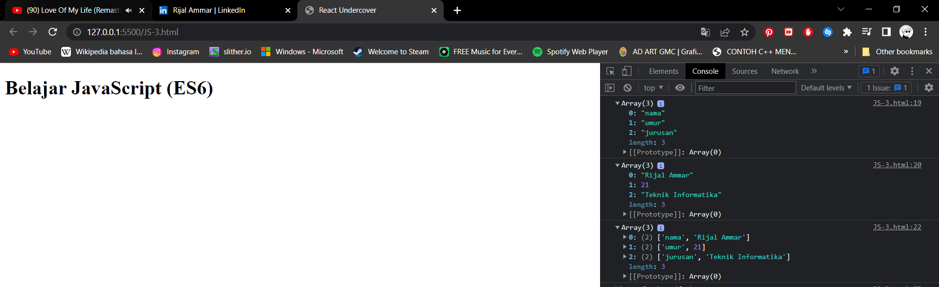

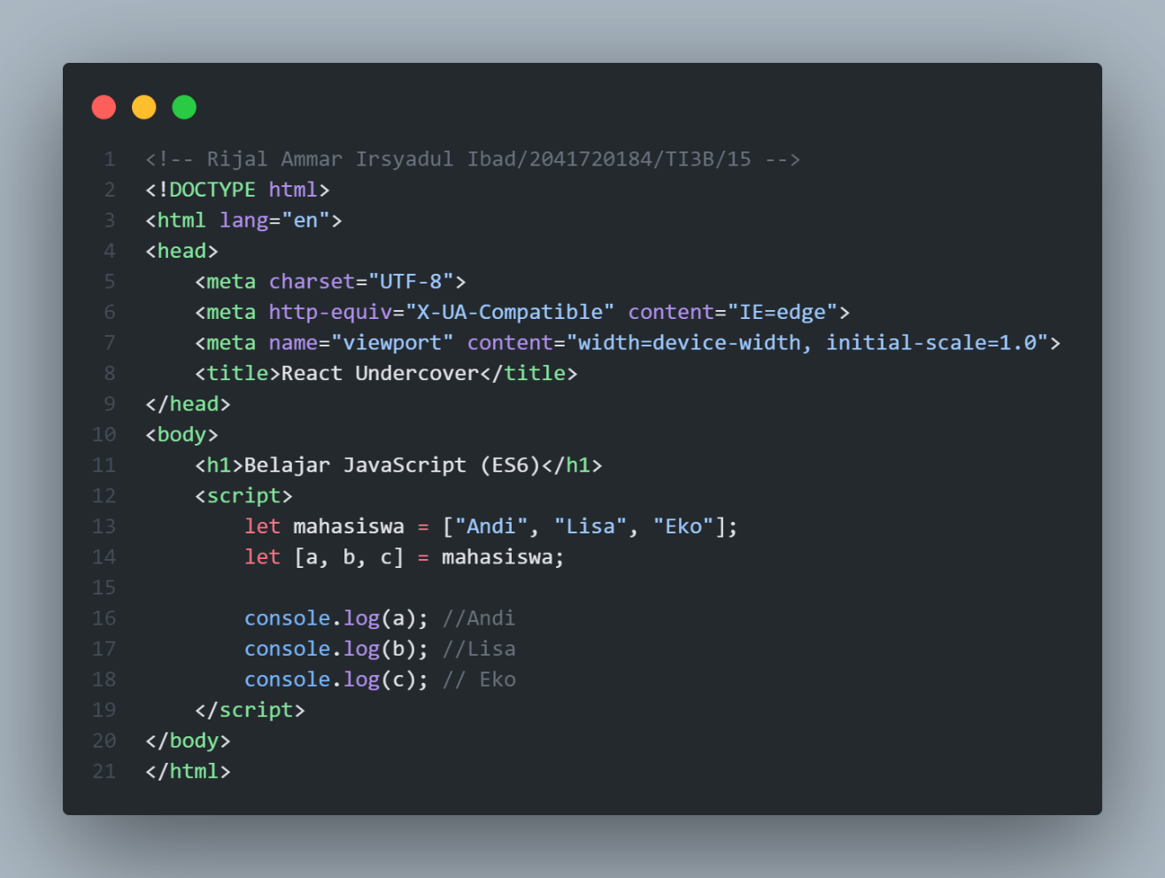

**Array dan object destructuring adalah perintah khusus untuk "membuka" nilai yang tersimpan di dalam sebuah array atau object ke dalam variabel terpisah. Di baris 11 variabel mahasiswa saya input dengan array 3 element, Kemudian di baris 12 terdapat perintah array destructuring untuk memindahkan setiap element array mahasiswa, Dengan perintah ini, string "Andi" akan tersimpan ke dalam variabel a, string "Lisa" ke variabel b, dan string "Eko" ke variabel c.**

1. **Array dan Object Destructuring**

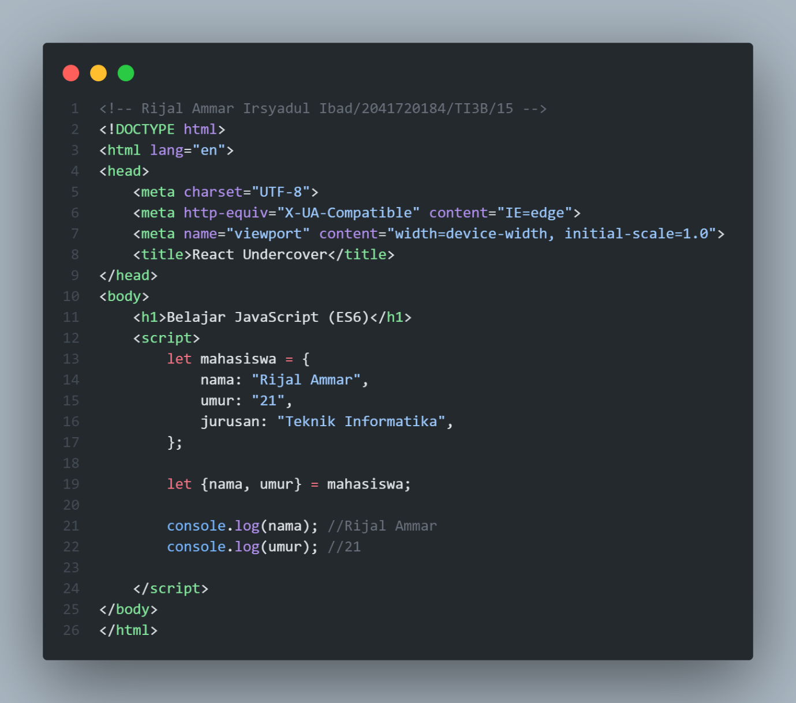

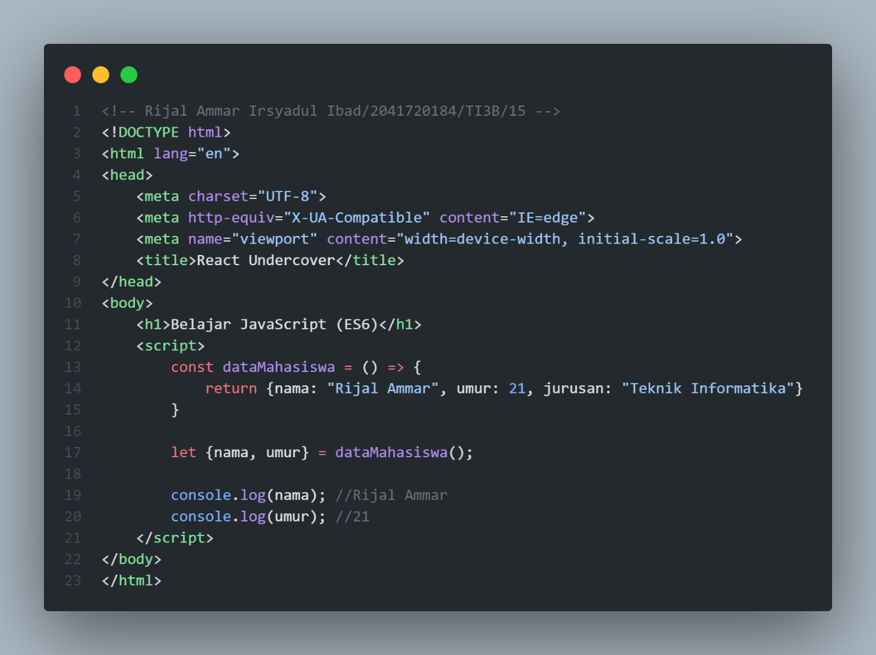

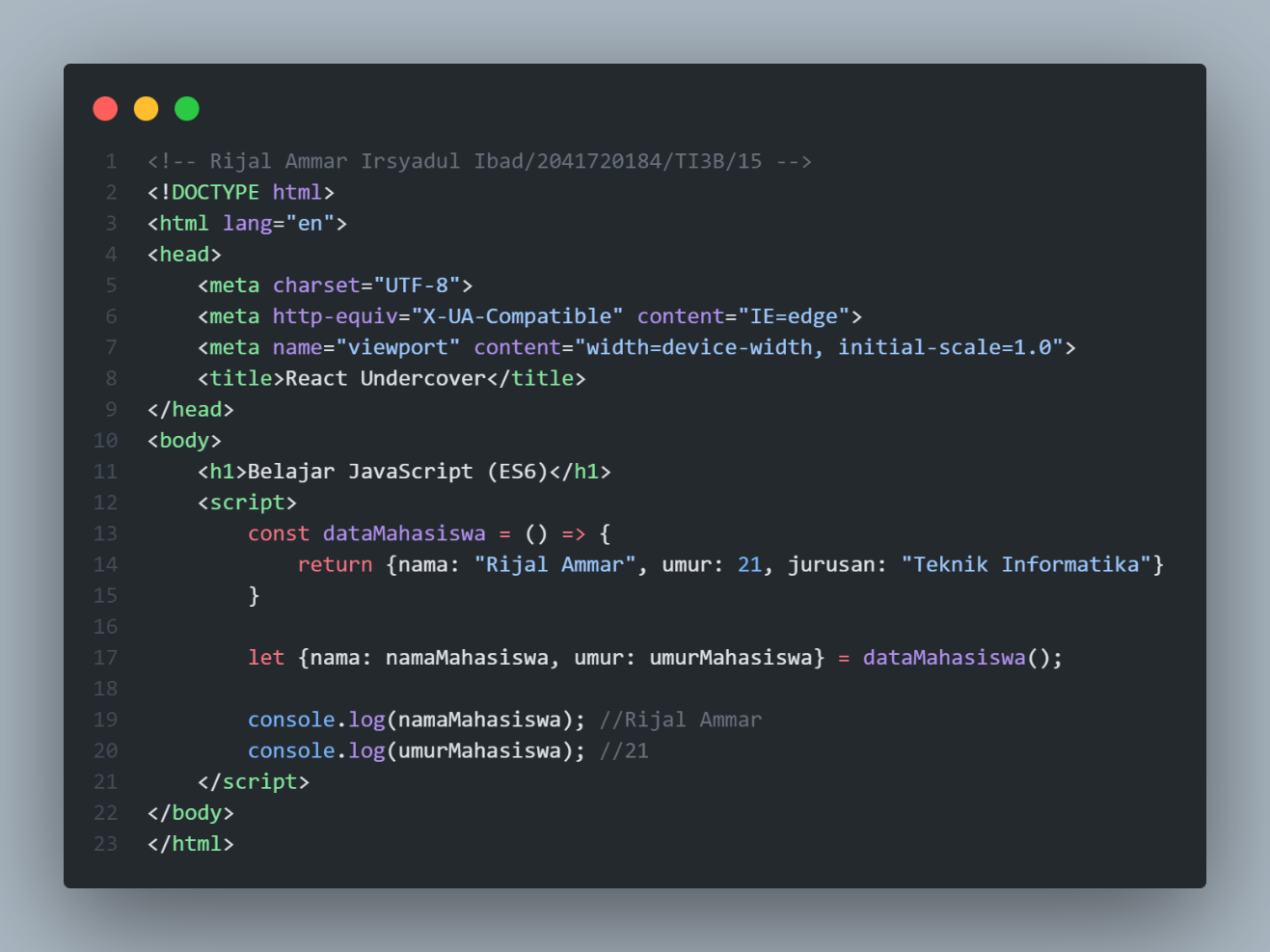

1. **Array Method: forEach() dan map()**

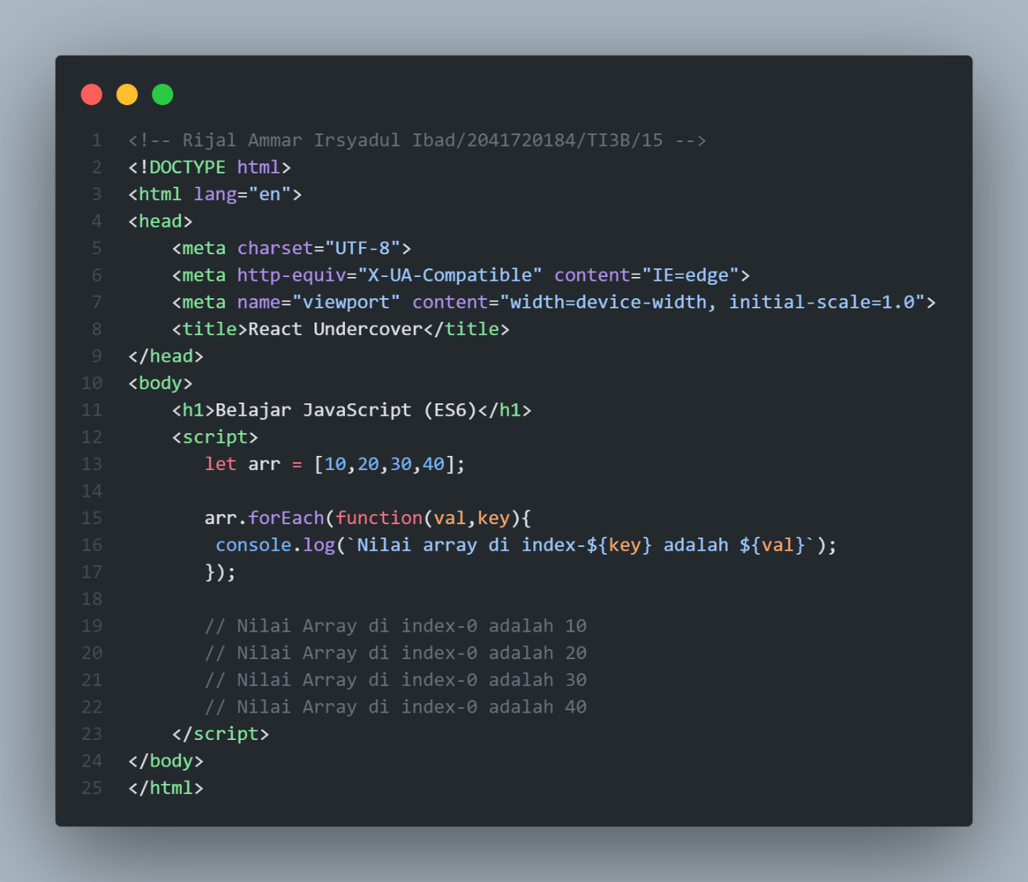

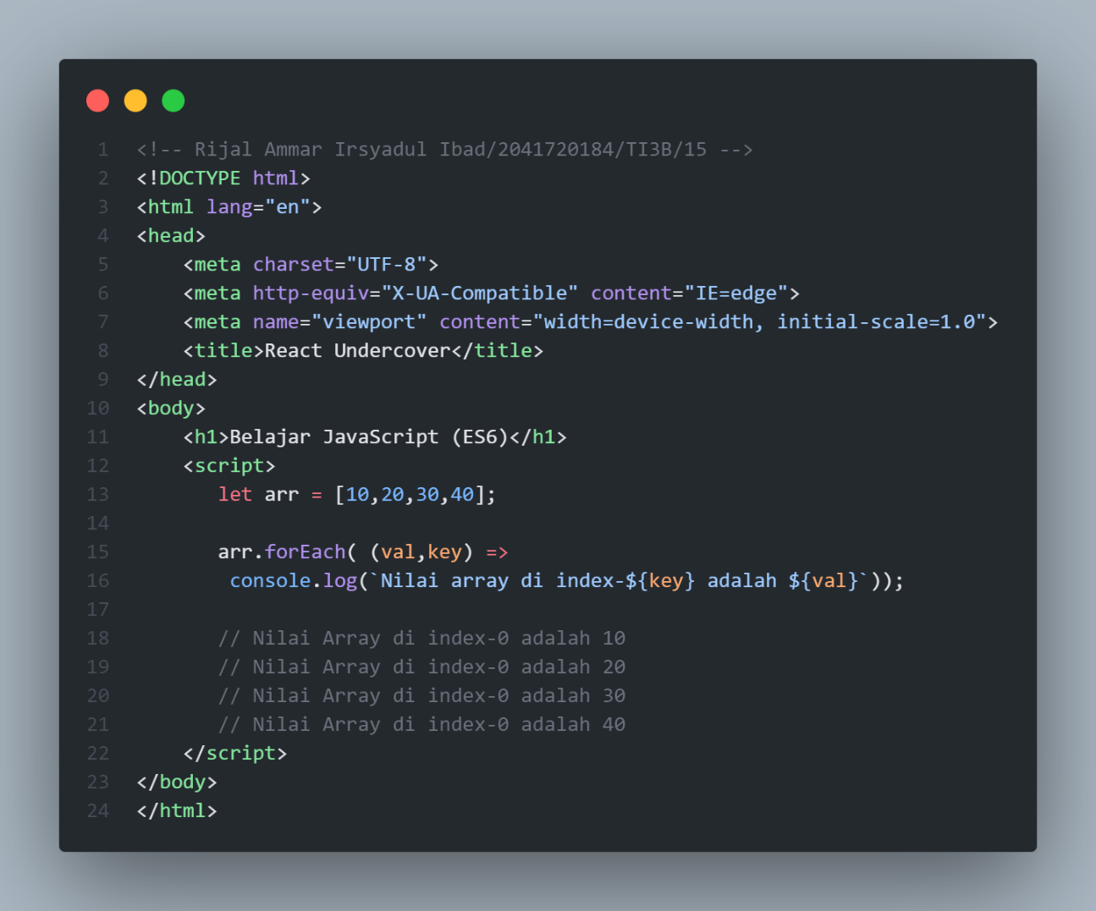

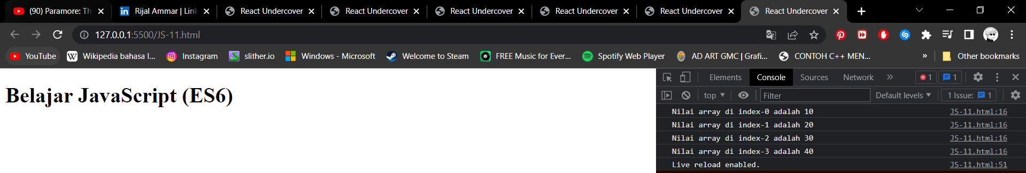

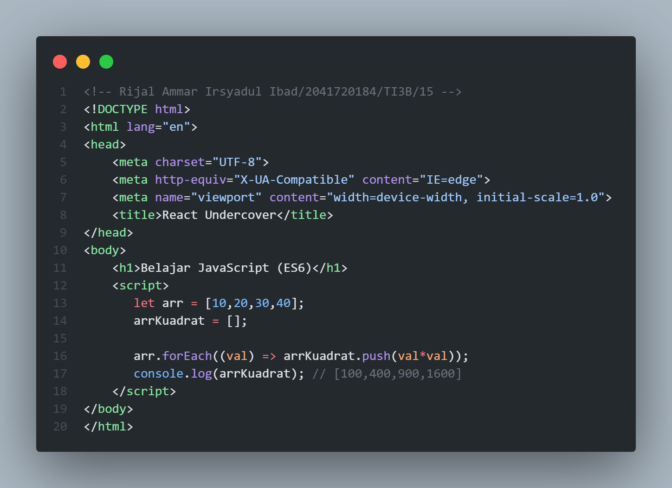

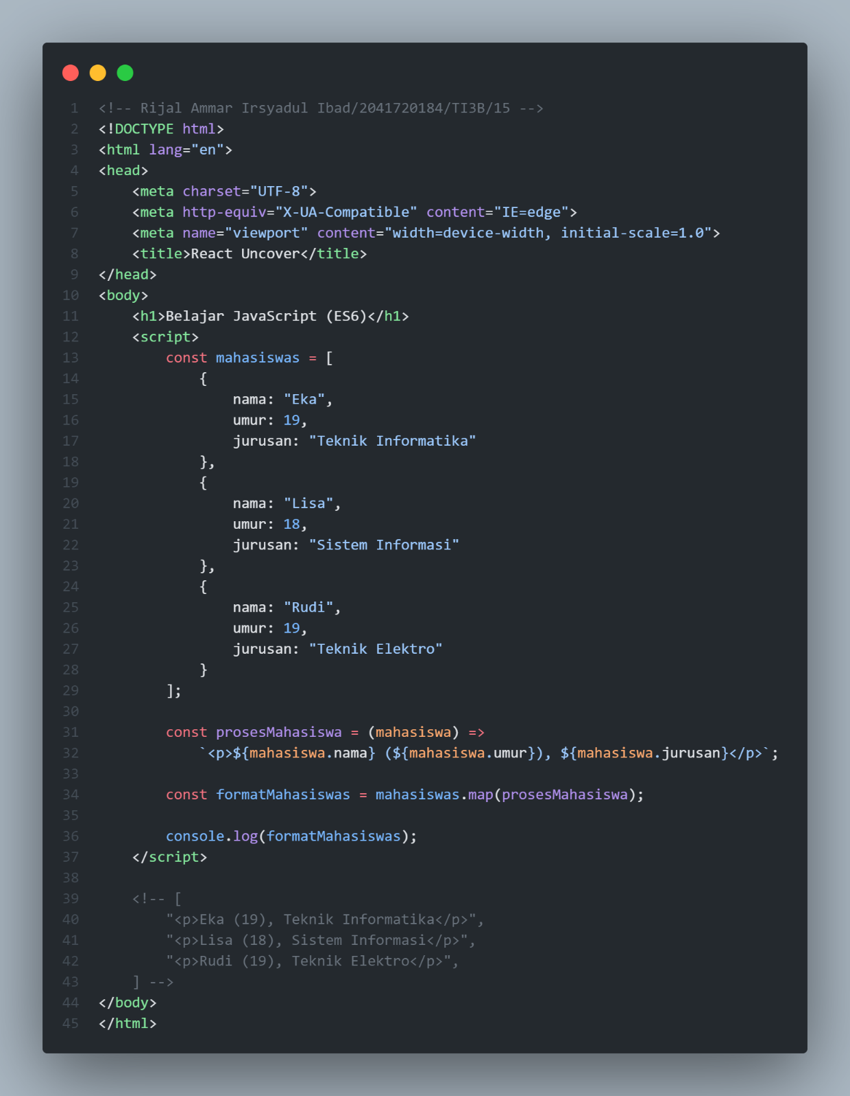

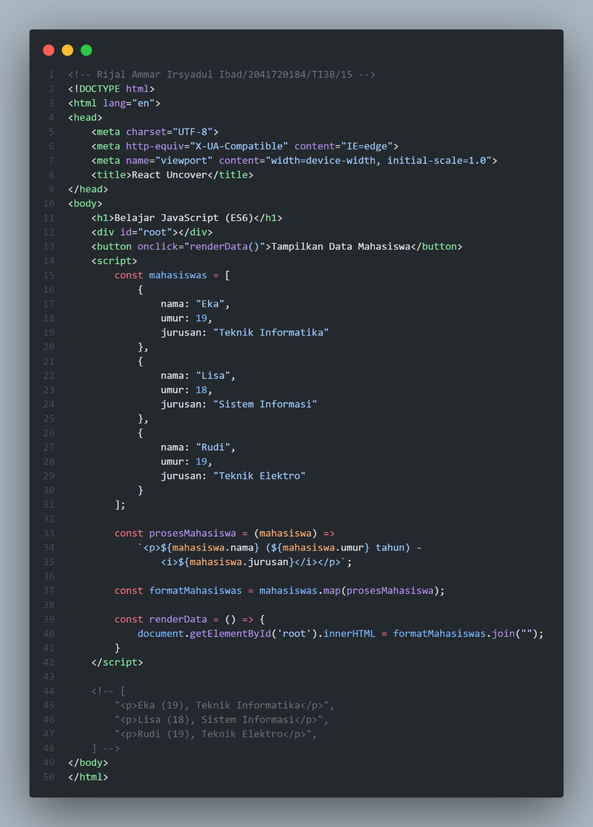

1. **Asynchronous JavaScript (Promise / Async - Await)**

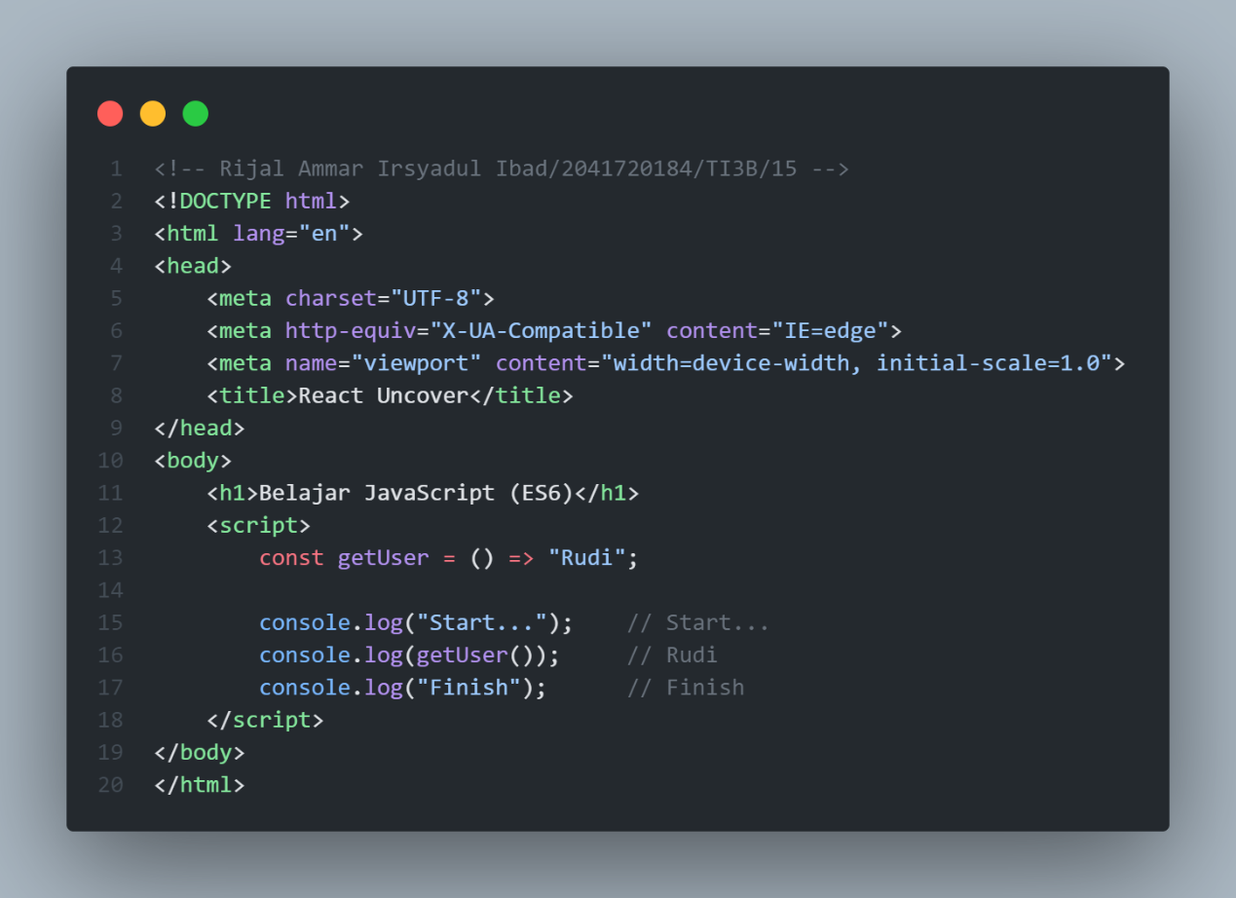

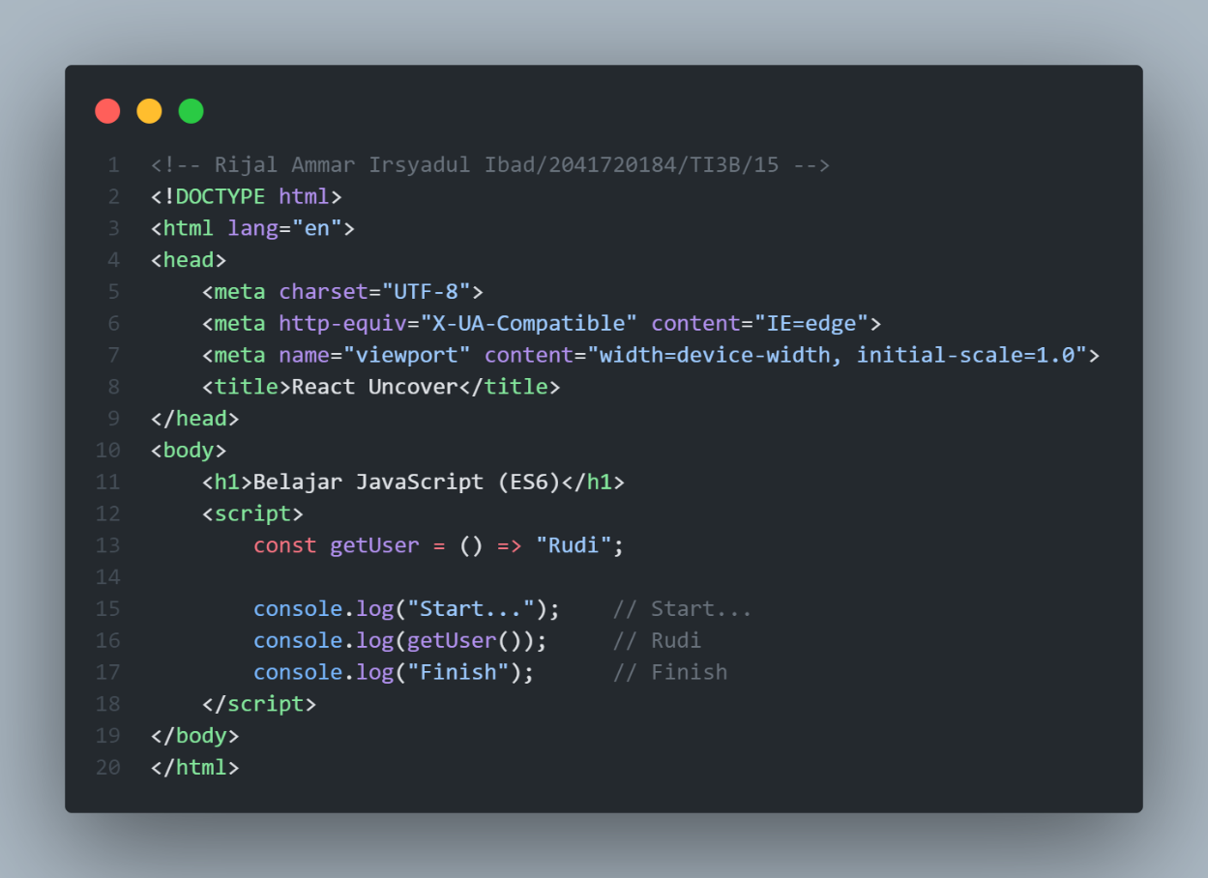

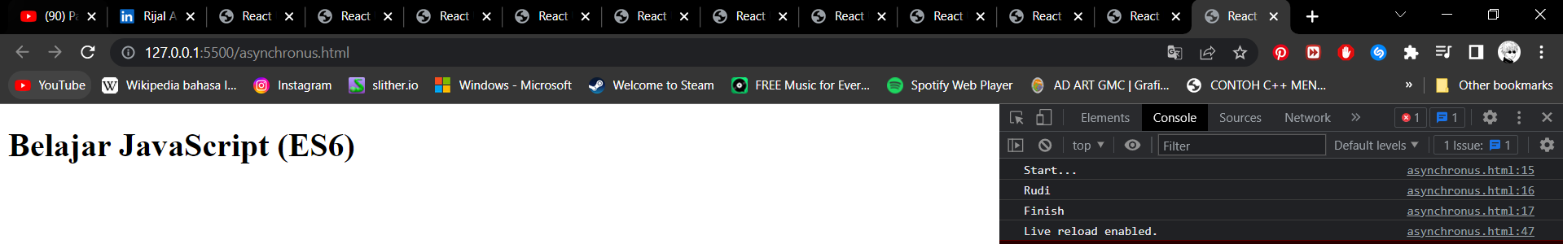

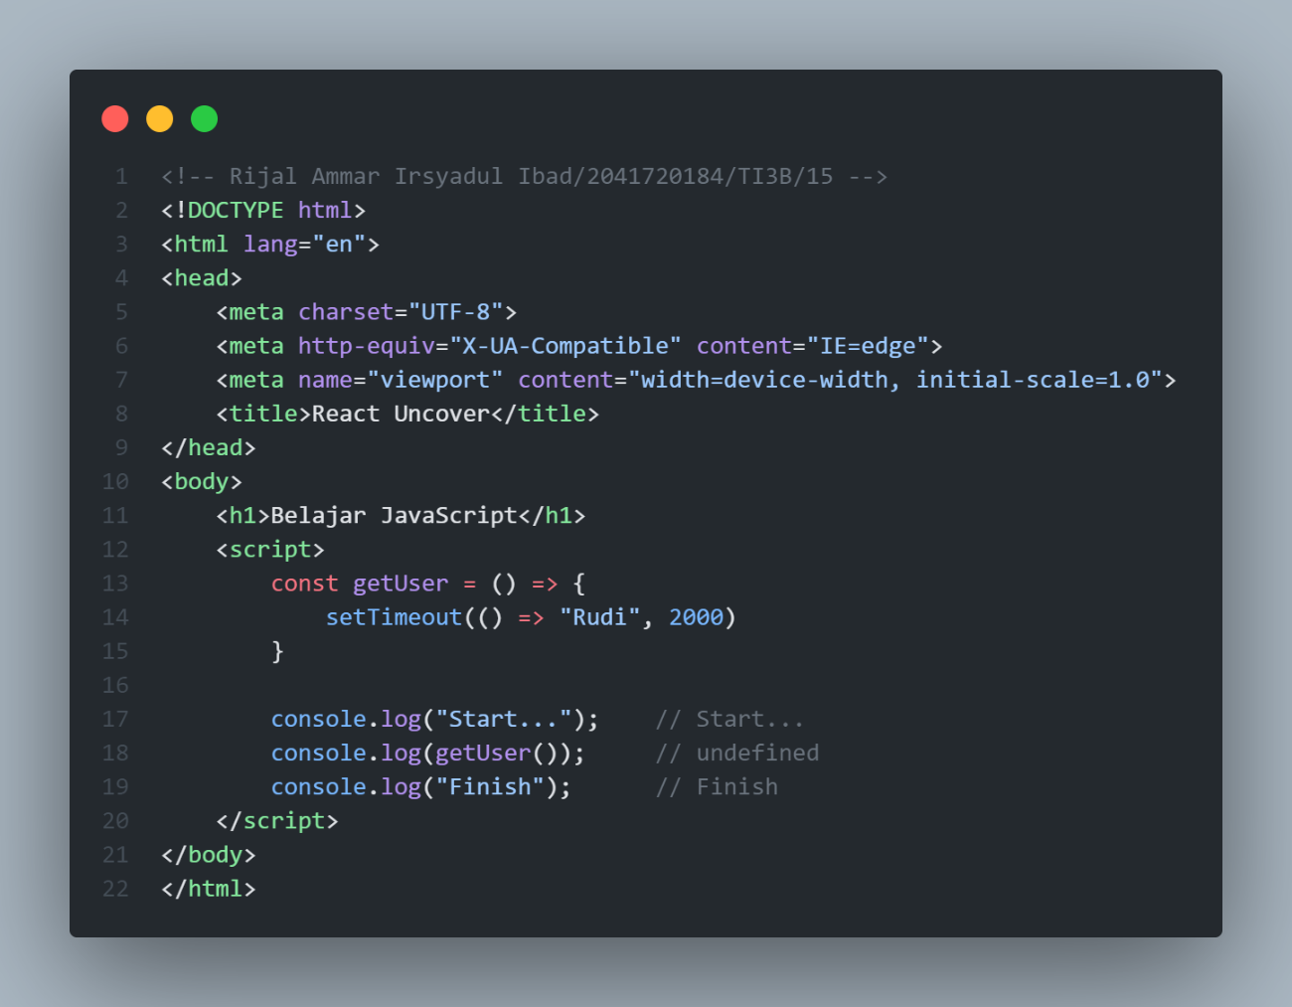

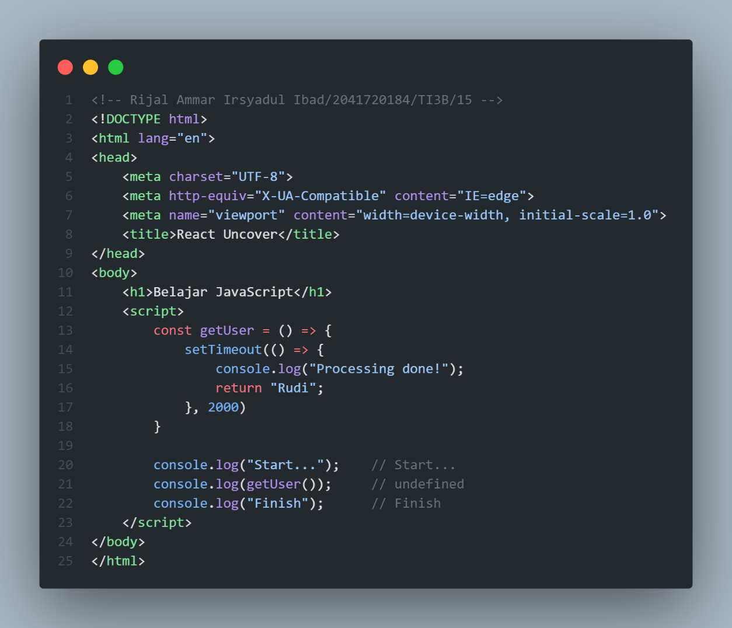

1. **Asynchronous JavaScript (Promise / Async - Await)**

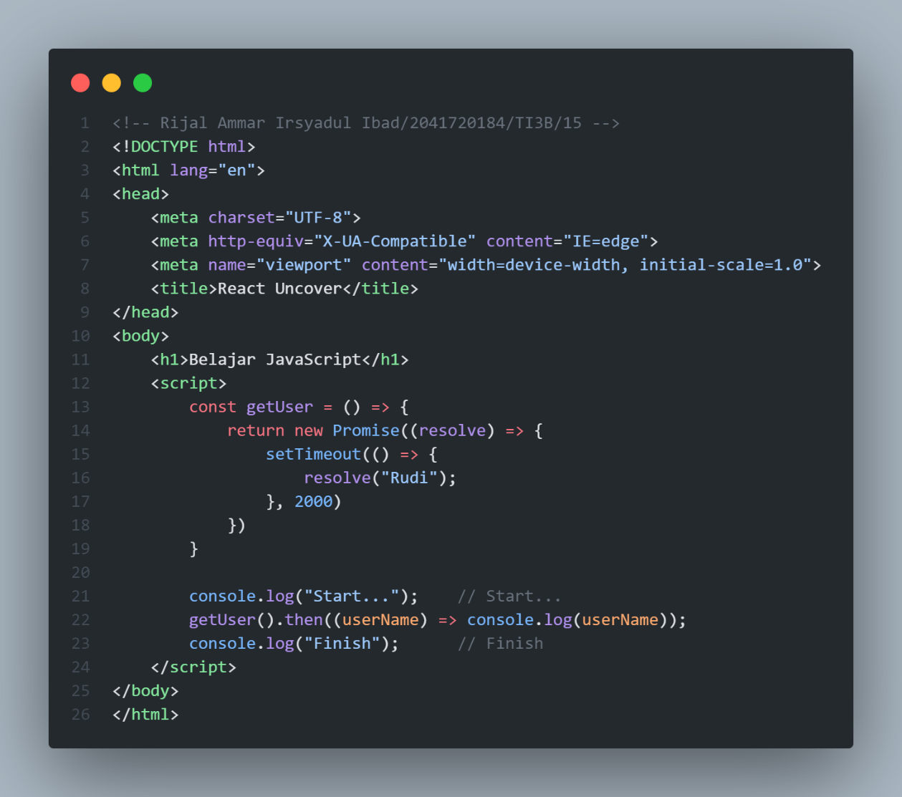

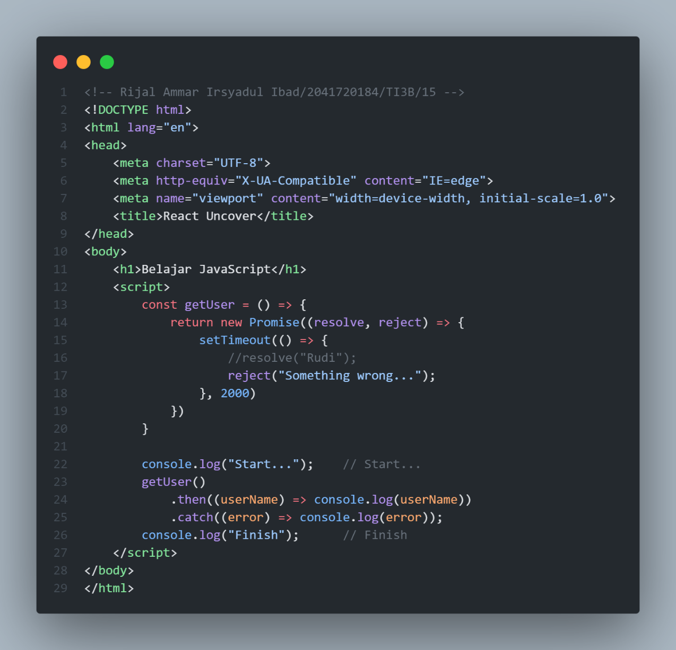

1. **Async – Await**



